EVE Online Functionality
Cheat Sheet
The most important things an EVE tester needs to know

Table of Contents
The Insider Bar 4
Slash Commands 4
Copycat 5
ESP explained 8
OK, I’m on ESP. Now what? 8
Locating a User account on ESP 8
The User’s page 9
The Character page 9
Deleting a character 10
Character page menu 10
Events (Log) 10
Moving a character through ESP 11
Changing Corporation via ESP 11
Testing folders for e4e 13
Best practices 13
Defect Template 14
How to determine what start build i should be using when entering a defect? 16
EVE Test Servers 17
ApTest 18
About ApTest 18
Navigating ApTest: 18
Importing into ApTest: 19
Running Tests: 19
Starting a ‘Test Session’: 19
Running the session you’ve just created: 22
Completing ‘Test Cases’: 23
Resuming Tests: 24
Appending Tests: 25
How to create your Defect attachments on the Mac 26
Screenshots 26
Log Files 26
System Details 27

<h4> The Insider Bar </h4>

The insider bar contains various useful tools that are invaluable to a tester, providing many shortcuts and cheats that allow the tester to quickly create or destroy ships, modules, items and NPCs, amoungst various other features. To have access to the insider bar the account you are using must have various GM roles applied to it, these are normally applied as standard but if the insider bar is not visible, first check that it not simply toggled off, by right clicking on the Neocom bar and selecting ‚ `toggle insider‘. If this option is not available then it is likely that the account you are using does not have the necesary roles, and you should contact your team lead or second to get the roles asigned. </p>

<h4>Slash Commands </h4>

Slash commands are what testers of EVE online use in order to speed up the entire process of testing. They allow a tester to travel over systems instantaneously, create ships, items, in game money (ISK), have super characters etc that would otherwise take a long time to acquire. </p>
There are so many slash commands that this list could turn into at least 5 pages of documentation so the following slash commands are the basics to introduce a new tester to the world of EVE online. </p>

<img src=“slash.jpg” /> </p>
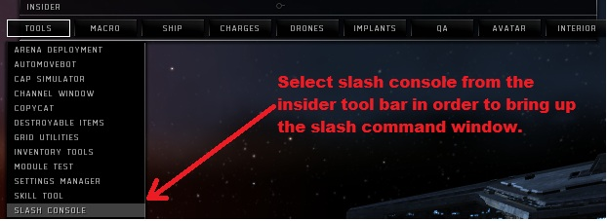
*note – Brackets are not needed. </p>
/tr me (enter system name) <b>This allows the player to travel instantaneously to another location. </b> </p>
e.g. </b>/tr me Rens </br>
/tr “Charactor Name” Rens “REASON FOR TRANSFER”</b> </p>

/credit concord me (amount) <b>gives player in-game money (ISK) </b> </p>
e.g. <b>/credit concord me 100000000 </br>
/credit concord “Charactor Name” 10000000 “REASON FOR TRANSFER”</b> </p>

/create (“ship” or “item”) e.g. (“Maller” for ship or “foxfire rocket” (quantity) for items) <b> Creating items will place them in the cargo hold of the current active ship. This can cause problems as it allows your cargo to be overloaded, which prevents a player from doing certain things. </b> </p>
/load me (“ship” or “item”) -<b> This will only allow an item within the active ship’s cargo capacity to be given. </b> </p>
/spawn (ship) - <b>Only used in space, which will spawn a ship right next to the player. </b> </p>
/Heal me - <b>Quick heal command. Heals hull, armor and shield to 100%. </b> </p>
/super me -<b>Maxes out the characters skill points allowing them to do/use anything in the game</b> </p>
/noob me - <b>Sets characters skill points to 0. </b> </p>
/ hop (distance in meters) -<b> Jumps the player in the direction they are moving by the value set. </b> </p>
/online me - <b>Activates all offline modules on a ship. </b> </p>
/crimewatch clearall me -<b> Clears all criminal flags on the player</b> </p>
/nuke – <b>kills all enemies within player radius. </b> </p>
/fit me (“item”) - <b>Fits the user specified item to the players ship. </b> </p>
For more slash commands click on the following link: <a href="https://partnerwiki.ccpgames.com/externalqa/eve/wiki/Slash_Commands.html"><u> EVE Wiki Slash Commands </u></a> </p>
*tip : pressing up on the arrow keys after clicking on the command line will repeat the last slash command that you entered into the command window. </p>

<h4>Copycat </h4>

Copycat is a useful tool for spawning fully fitted ships instantaneously. When using a slash commands to spawn or load a ship, the player only ever receives a blank ship hull without any modules fitted and as such getting a fully fitted ship can be time consuming. </p>

<img src="copycat_insider.jpg" /> </p>

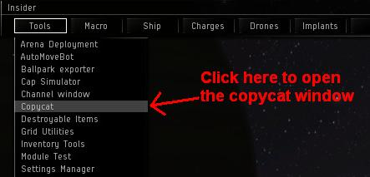
When the copycat window opens it should look something like this: </p>

<img src="copycat.jpg" /> </p>

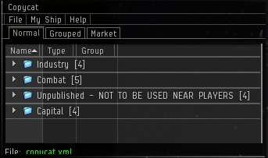
Displayed is a list of subfolders containing various fully fitted ships provided by CCP that can be used for various different purposes, from combat ships used for combat missions or PvP to industrial ships used for mining and the hauling of large amounts of materials. </p>

<h4> Adding other ships to copycat </h4>

For the purposes of some scripts or just due to personal preference, it may sometimes be necessary to add ships to copycat, so that they can easily by accessed at anytime or to save time fitting ships for scripts. To facilitate this, copycat uses unique keycodes for each ship that contain all the information on the ship and its fitting, these are called <b>DNA Keys</b>. To add a ship using its DNA key firstly copy it to your computers dashboard. Then in the copycat window select File->Import->DNA from clipboard. </p>

<img src="copycat_import.jpg" /> </p>
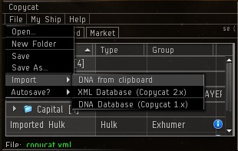
A window appears which allows you to give the fitted ship a unique name. Once named, the ship will appear in the copycat window as standard. </p>
Websites

(You should bookmark them all in your browser)
http://esil.ccpgames.com/ - Server info for EVE online.
https://bugs.eveonline.com – Defect tracker used to submit any found defects.
http://uk-image/ - For entering how many hours you have worked. To be done before 10.00am every Friday.
https://partnerwiki.ccpgames.com/externalqa/eve/wiki/Category_ExternalQA.html - Vast index knowledgebase for EVE testing. Very useful
http://qawiki/index.php/Main_Page - e4e Wiki - Wiki contains all of the documentation, procedures, “how to” and training material.

<h4>ESP explained</h4>
ESP is a web based tool used to find or change anything in EVE like dungeons, nodes, items, corps, player accounts, player petitions and much more. Each server has its very own ESP address and can be found by simply clicking on the server name located on <a href=“http://esil.ccpgames.com/”> <u>http://esil.ccpgames.com/</a></u> </p>

<img src=“esil.jpg”> </p>
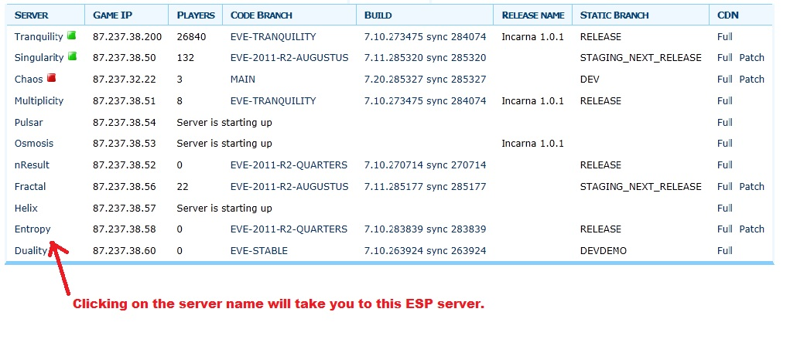
<a id=“esp“/>

<h4>First Steps</h4>
The first page of ESP will show the tester: </p>
<ul>
- <li>A server population chart </li>
- <li>The “Tunnel to POLARIS” link</li>
- <li>The current server information (Code branch and build version) </li>
- <li>The server list (Used to find out which systems are on a different node) </li>
</ul>
Start off by clicking on the “Tunnel to POLARIS” link. You will then be prompted to enter a username and password. Don’t forget that if you are logged into EVE with an account, that it will be logged out if you use the same account to log into ESP. After logging into ESP you will notice that more options have been added to the menu at the upper right side of the screen. </p>

<img src=“esp_menu.jpg”> </p>
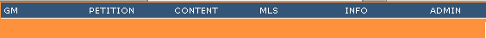

<a id=“esp_locating“/>

<h4>Locating a User account on ESP</h4>

After the tester has logged in, they will probably want to edit a User/Character in some way. To access the User search form, click on the “Users” link under the “Shared” heading on the ESP homepage. </p>

<img src=“esp_shared.jpg”> </p>
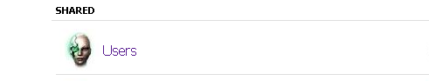
To locate a User, just begin typing their full Username into the search box. It will auto-complete and give the user a drop down menu of possible results. </p>

<img src=”esp_select.jpg” />
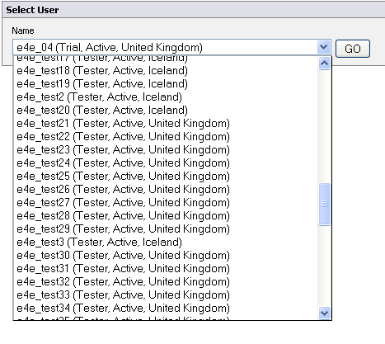

<a id=“esp_user“/>

<h4>The User’s page</h4>
After selecting a User, the tester will be taken to the User’s page which lists all of the User’s info, their current characters and menus of various pages that edit the User account in different ways (located on the far left and right sides of the screen. </p>
<img src=”esp_user.jpg” />
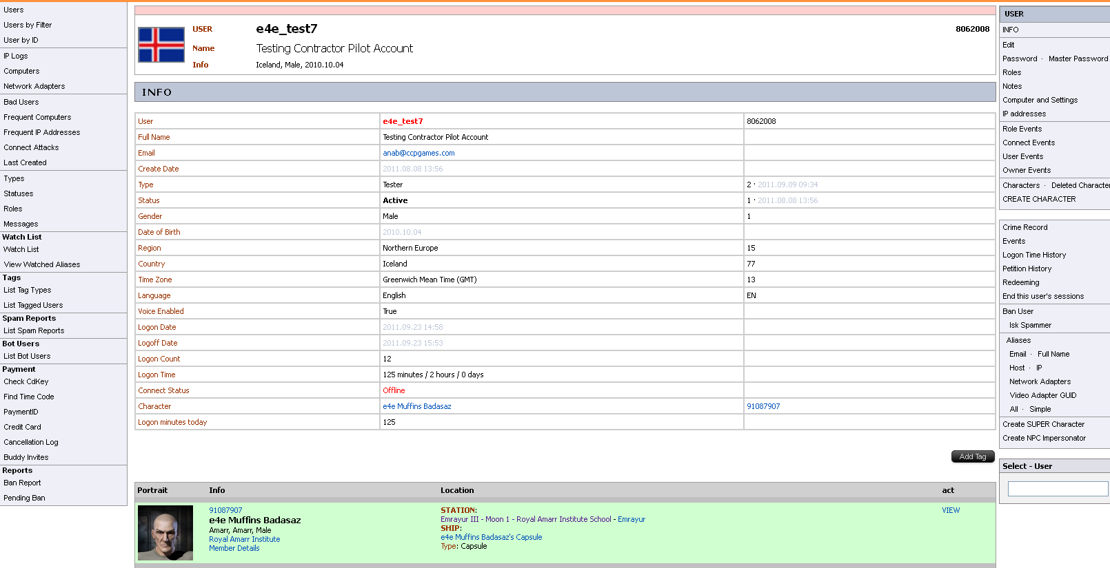

<h4>The Character page</h4>
After finding a User’s page, the tester can drill down further to look at each of their character’s pages by clicking the “VIEW” link next to the chosen character.</p>
<img src=”esp_character.jpg”/>
Having selected the “VIEW” link, the tester should now be looking at the actual Character page. This looks very similar to the User page that the tester has just left. It contains all the info for the selected character as well as a VERY useful options menu that runs along the right side of the page. </p>
<h4>Deleting a character </h4>

The most important thing to remember is that a character <b>cannot be deleted if they are the CEO of a corporation.</b></p>

A character can also be deleted remotely via ESP. This must be done from that particular character’s page. Just below the main info table for the character, you will see a red button that says “Prepare Remove”.</p>

After clicking the button, the tester will be taken to a new page with only a gray button that says the same thing. After clicking that, the tester will be shown a pop up asking “Are you sure?”, if they click the OK button they will be taken back to the Character’s page and will see two new buttons below the Character info. The “Cancel Prepare Move” and Remove” buttons.

After the tester has clicked the “Remove” button they are taken to a new page that only has a gray “Remove Character” button. After clicking the “Remove Character” button, the tester is shown another pop up that asks “Are you sure?” click “OK”.
The character has now been deleted and the character slot in the client is now empty.

Character page menu
Let me take you on a magical adventure now, and I will attempt to explain some of the more commonly used options of the Character page menu.

Events (Log)
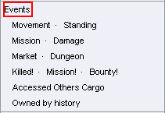
The “Events” link will take the tester to a page that will show them a log of EVERYTHING the character has done or has had done to them. That includes movement, slash command usage, ships destroyed, dungeons entered, etc.

Moving a character through ESP
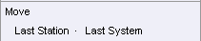
- The “Last Station” link: Clicking this will move a character from their current station to the last station that they have docked in.
- The “Last System” link: Clicking this will move a character from their current solar system to the last solar system that they were in.
- The “Move” link: Clicking the “Move” link will open a new page that will allow the tester to move a character to a chosen solar system, space station or world space. These text entry fields will auto-complete after a few letters have been entered and may allow the user to select an option from a drop down list if enough options are available (much like the User search).
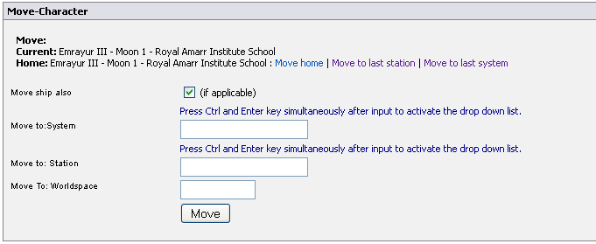
Changing Corporation via ESP (CAN NOT BE DONE IF THE CHARACTER IS CEO OF A CORP!)
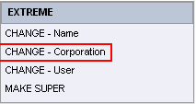
Located in the bottom right corner of the Character page, are the EXTREME options. One of the options allows the tester to change the corporation that a character is currently in, this is “CHANGE - Corporation”. Clicking the link will bring the tester to a new page with a form that looks like this:
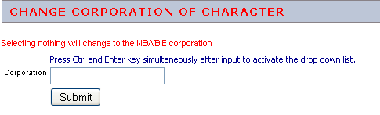
Like most text entry forms in ESP, this will auto-complete after the tester enters a few letters and allow them to select a corporation or faction from the drop down list. As you can see from the screenshot above, if the tester just clicks the “Submit” button, they will be added to a random NPC corporation.

Testing folders for e4e
Here we can find all the documents that EVE testers will need to make their job easier. By searching or clicking on this link \\uk-fs2 you will be directed to network. Double click on the folders Tester_Access/CCP. You should now be in our main work folder where you should right click and make a shortcut for the following to your desktop: EVE documentation, reporting, and patches.

Best practices
This is a non exhaustive list of best practises to use when testing EVE Online. All points contained herein should be followed at all times. Very important procedure for new testers.
http://qawiki/index.php/CCP_Testing_Best_Practices

Defect Template
Title:
Outpost: Station Management button disappears.

Description:
Reproducible on Pulsar, EVE-STABLE, 223928 (3/3)
Reproducible on Chaos, MAIN, 224921 (3/3)
Non Reproducible on Multiplicity, EVE-TRANQUILITY, 223454 (0/3)
When a player owns an outpost, they should be able to access station management. However, it was observed that if a player logs out of the server then back in, they will no longer have the "Station mgmt" button until they enter space then dock again.

Expected Result:
The station management button should always be accessible to whoever has the outpost.

Attached Files:
Screenshots
Logfile

Steps to reproduce:
Prerequisites
1. Make sure you have a player who is the CEO of a corp.
2. Find a 0.0 system that has a station.
Steps to Reproduce
1. Create a Test Territorial Claim Unit using /load me "test terr".
2. Right click on the TCU and select “Launch For Corp”.
3. Anchor the TCU then put online.
4. Using a ship with high DPS like a Phoenix with Citadel torpedo launchers, lock and fire at the station until shield, armor and structure have depleted.
5. Once the outpost has been claimed by the player corp, proceed to dock then log off the server.
6. Log back on and observe that the "Station mgmt" tab is no longer there (located on the bottom right of the station information UI).
7. Enter space then dock back again
8. Observe the station management button has reappeared.
Computer:
Windows XP Professional (5.1, Build 2600)
ATI Radeon HD 5700 Series
Driver:6.14.0010.7140 (English)

How to determine what start build i should be using when entering a defect?

START BUILDS -
3 January 2012
 |  |  |  |  | Repro on Multi?
 |  |  | No |  |  |  | Yes
 |  |  |  |  |  |  | Start Build - EVE-VITELLIUS
  Repro on Staging? (Pulsar / Sisi / Staging)
 | Yes |  |  |  | No
 | Start Build - TITUS |  |  |  | Repro on Chaos?
 |  |  | Yes |  |  |  | No
 |  |  | Start Build - NERO |  |  |  | Not a bug
 | Remember, this means that a defect found on Sisi must be checked against Multi.

EVE Test Servers

EVE QA use many different test servers to ensure that the various branches of code that are in development at the same time can be tested. The way that these servers break down is as follows, though please note that this information is subject to change and should be used only as a rough guide.

Singularity - 87.237.38.50 – The Public test server. It is the largest test cluster and is used primarily to debut features in development so that they can be exposed to wider coverage and a greater spread of hardware than is feasible for internal QA to be able to cover. The database is mirrored from Tranquility‘s database quite regularly, though it is pruned of sensitive data.
Multiplicity - 87.237.38.51 – The TQ reference server. Multiplicity usually runs the latest version of TQ although can also be used to test hotfixes prior to live deployment. It is mirrored from TQ like Singularity, but with less regularity. In general defects should always be reproduced on Multiplicity as a bare minimum before they are entered into the database.
Chaos - 87.237.38.55 – The principle development server. Chaos runs the MAIN branch of code and is used to test the development of the next expansion. Chaos runs on its own database and is not TQ mirrored. Bug hunters have access to Chaos as well as to Multiplicity and Singularity.
Pulsar - 87.237.38.54 – Usually found running EVE-STABLE, Pulsar is the main server for running regression sprints on. A „demo” build is created at the beginning of each sprint from MAIN (or other servers as appropriate) and placed on Helix and Pulsar.
Helix - 87.237.38.57 – Helix is the principle demo server for CCP. Each sprint a new build is created and the scrum teams will demo their progress to the stakeholders, as well as anyone who wishes to attend. They will then answer questions about their features. It is rare for the server to be used externally.
Fractal - 87.237.38.56 – Fractal is normally found running the latest staging build of the upcoming release. For certain releases, or if a faulty demo build has been made, it will be used for regression sprints. Due to the frequency of updates (usually daily) Fractal receives it is being considered to replace Pulsar as the primary sprint server.
Duality - 87.237.38.56 – Singularity‘s „little brother“ is the other, newer Public Test Server (although it is only semi-public). Initially conceived of to host the mass tests and other large events, it has spent a lot of time in VIP mode lately due to the lack of mass testing required by the upcoming release. While in this mode it serves as any other test server and runs the STABLE build more often than not. Like Singularity, it is mirrored from the TQ database.

ApTest

About ApTest

ApTest Manager is an application designed for providing testing and analysis over the internet for projects in development.
This manager uses ‘Suites’ which are a collection of ‘Test Cases’ (individual procedures for testing functionality) and each ‘Suite’ usually represents a different project in development.
‘Test Cases’ in these ‘Suites’ can be organised into folders and folder hierarchies known as ‘Scripts’ which are intended to test different aspects and areas of the project.
You can select these ‘Test Cases’ and run them to test functions and features of the project, by doing so you create a ‘Test Session’ which is a collection of ‘Test Cases’ that have been selected to run. This ‘Test Session’ allows testers to mark when ‘Test Cases’ pass, fail or can’t be started, how long these tests take, report bugs and make notes about individual tests.
The ‘Test Session’ can also show the percentage of completed tests, how many pass and fail, any notes and bug reported for the test as well as the expected time and actual time for completing the ‘Test Session’. This useful for Team Leads to monitor testing and ensure that targets and deadlines are being met.

Navigating ApTest:

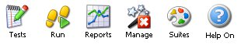
These are the five buttons used for navigating through ApTest. They are in the top-right corner of the window.
- Tests – Takes you to the window that displays the ‘Test Cases’. This contains a panel on the left showing the ‘Script’ hierarchy and the panel on the right displaying folders and ‘Test Cases’. This is where you import, edit and run individual Test Cases.
- Run – Here you can view ‘Test Sessions’ that have been created. Here you can run and edit ‘Test Sessions’
- Reports – Here reports can be generated using ‘Test Sessions’. For team leads.
- Manage – Here are the setting for the suite. Only an admin can edit these.
- Suites – Here you can select different ‘Suites’ to run tests in.
- Help on – This button load a help bar on the right of the screen.

Importing into ApTest:

Ensure that all commas are removed from the “Test Procedure” and “Verification” columns of Excel spreadsheet before saving as a CSV file. If these are not removed this can cause Test Cases to have sub-steps.
Make sure the “Test Case” titles are of the format “xxx [Script name]” where xxx represents the test number in a three digit format e.g. 001, 022, 333 etc.
When importing only one ‘Feature’ can be entered into the ‘Feature’ field of the spreadsheet, if other features are associated with ‘Test Case’ they should be added to ApTest manually.
If you are importing a Script into a folder that already contains a previous version of the Script it is best to delete the previous version and import the new one.

Running Tests:

Starting a ‘Test Session’:
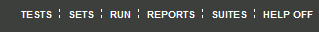
First you need to navigate to the script selection screen, by clicking on the “TESTS” link in the top menu.
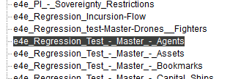
Once on that screen, select the script you want to run from the list on the left.
Some of these might have subfolders (Incursions, PI, Customs, etc)
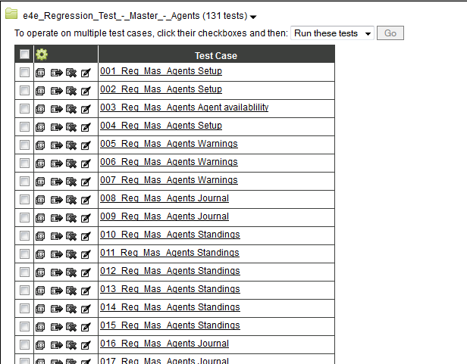
Action Drop-down Menu

The test cases of that script should now be listed in the right panel.
Using the tick boxes, you can choose individual test cases to run or select the tick box at the top to run all of them.
Once you have selected the desired test cases, select “Run these tests” from the Action Drop-down Menu and click “Go”.

You should then be brought to the “Run Session” page, where you must name your session for ease of recognition (you’ll need to, there are hundreds of sessions). The convention to be adopted is “[Task] – [ScriptName]” (for reviewing use “[ScriptName] – Review”). Comments are not necessary.
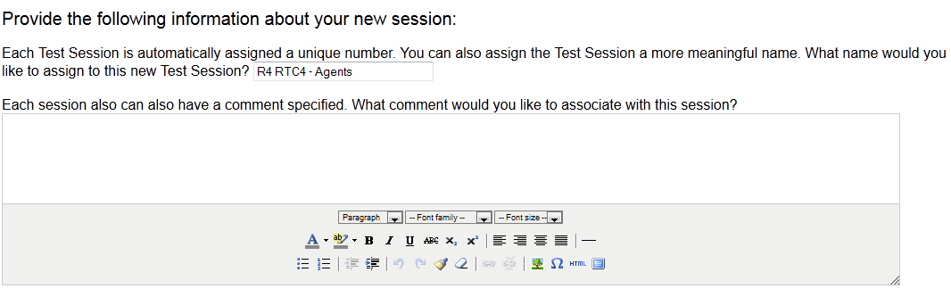
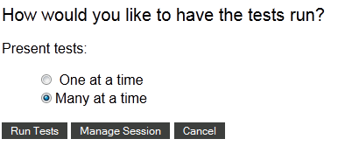
Lower on the same page you shall be asked how you wish to run the script.
You can run the test cases one at a time, although many at a time will allow you to plan ahead.
Once you have selected one of these options, click “Manage Session”.
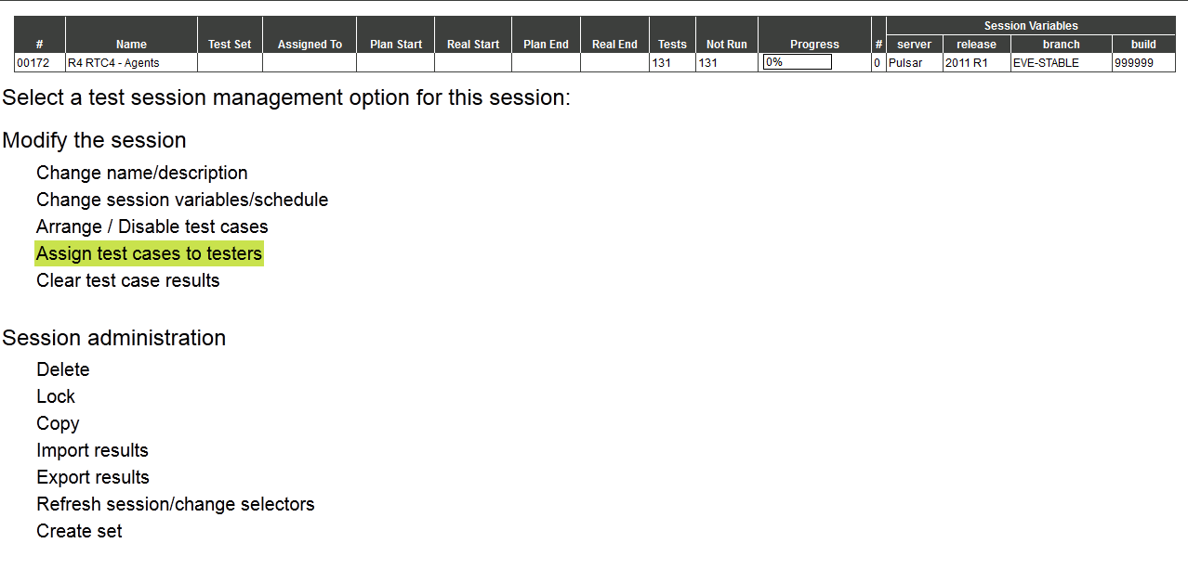
The first thing you want to do is set your session variables so that they match your current test server. If not, they will remain at the default values shown above. See a) for instructions.
The next task is to filter out the proper test types. Although these can be set through advanced filters, this way ensures that there are no errors (for example, if there is a test case with no test type, the advanced filters will remove it, and you might miss some steps). See b) for instructions.
The final step is to assign test cases to yourself. This allows the ApTest Manager to extract various metrics from all the sessions, and also helps you find your session in the list. See c) for instructions.

a) Setting Session Variables
By default your session Variables are as follows:
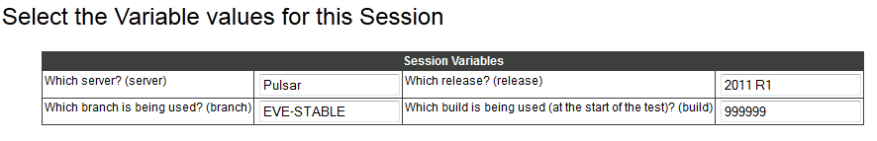
Simply replace each entry box with the details from the test server you are currently working on:
For example: Server: Singularity (the main focus of the sprint)
Release: 2011-CALIGULA (start server release)
Branch: EVE-2011-R4-CALIGULA (this can be found on ESIL)
Build: 312067 (this can be found on ESIL)

Once you have set the correct values, select “Change Values” 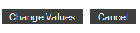

b) Filtering Test Cases
Some scripts contain several different Test Types, and in some cases the Test Type field is left empty. This function allows you to choose exactly what test cases you wish to run.
For example, if you wish to not run any Extended Regressions: 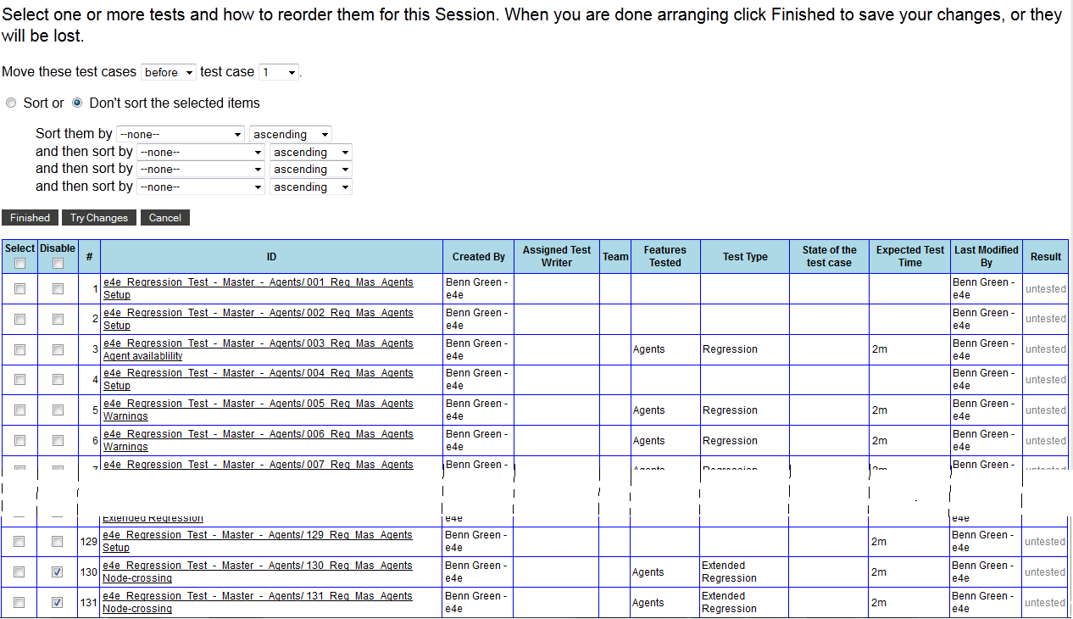
In the list you can select any test case you wish to remove from the session by clicking the tick box next to it in the Disable column.
Once your selection finished, click the “Finished” button.

c) Assigning Test Cases
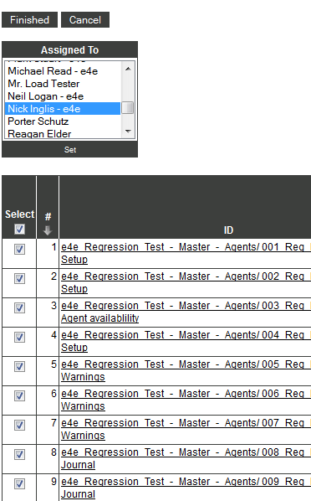
The fastest way to assign a script to yourself is to tick the top box just under Select, to select all test cases, then find your name/username in the “Assigned To” list and click on it.
Once all is ready, click the “Set” button.
You should now see the name you selected listed in the Assigned To column next to the test cases you selected previously.

To accept the changes and return to the Manage Test Session screen, click the “Finished” button.

Running the session you’ve just created:

Close the Manage Test Session window, as you no longer need it. You should still have another window open, with the top menu present.
Click “RUN” in the top menu to be taken to the list of sessions, which should be displayed similarly to the following:
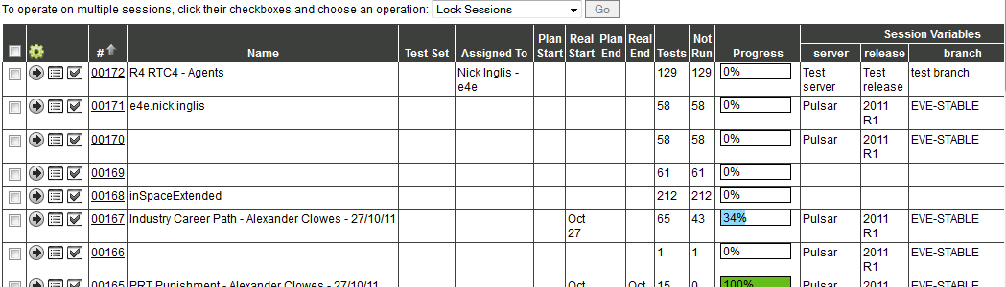
Your session should now be easily identifiable, with all the information you inputted: Name, Assignee, Server, Release, Branch, and Build.
To run the session, click on the little arrow next to the tick box.
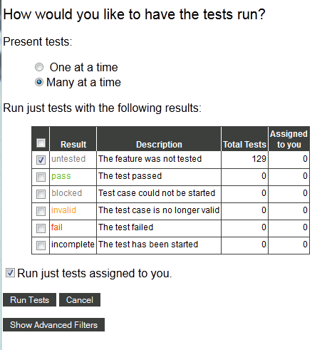
On the following screen, you can select how you want the tests to be presented, and which ones you want to run.
Ticking “Run just tests assigned to you” can make things easier if several testers are working on one same session.
Once your settings are selected, click the “Run Tests” button.
That’s all there is to it! ☺

Completing ‘Test Cases’:
When you have completed a Test Case you must mark the result of the test using the ‘Result’ drop down menu. You will mark it as one of the following:
- Untested – This feature was not tested.
- Pass - The test was successful and completed without any defects
- Blocked – This test could not be started either due to a missing precondition or inability to access the feature for testing.
- Invalid – This test is no longer valid and requires alteration
- Fail – The test fails due to defect in the feature.
- Incomplete – This test was started but not completed.
You must also mark down the time taken to complete this test, please be as accurate as possible.
If you have a test that contains some wait time (time need for certain features to activate) you should set the Test Case to Incomplete and move onto the next one if possible. If you cannot continue till the wait time is completed then start a different test and come back to this one later (see ‘Resuming Tests’).
Note: Wait Times are not to be recorded in ApTest, only time spent actually doing the test steps should be recorded.
If a test only contains a ‘Precondition and Setup’ but no ‘Test Procedure’ or ‘Verification’ then simply complete the steps mentioned in the Precondition and mark the Test as a pass.
If you find any problems or errors in the Test Case and do not have access to a Change log for the Script then make a note in the ‘Execution Notes’ for the case and continue the tests. If a defect is found when completing a ‘Test Case’ then report by your usual procedures, when you receive the defect number add it to the execution notes.

Resuming Tests:

If for any reason you have to close the Test window (e.g. restarting PC, internet busted etc) then you can resume a test by clicking the ‘Run’ button from the toolbar in the top-right of the screen, this will load a page listing all of the Test Sessions created. Scroll through the list until you find the Test Session with the name you gave it earlier. To the left of the name you will see three buttons that look like this:
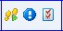
These buttons are the ‘Run Session’, ‘Session Summary’ and ‘Manage Session’ in that order.
Click the ‘Run Session’ button to launch a pop-up. This pop-up will list the different test states as well as the number of test cases with that status. Select the status of test you want to run. So if you want to continue from where you left off then select ‘untested’, if you want to retest failed tests then select ‘fail’ etc. You also have the option at the top to run the test cases one at a time or many at a time, you will usually want to do many at a time.
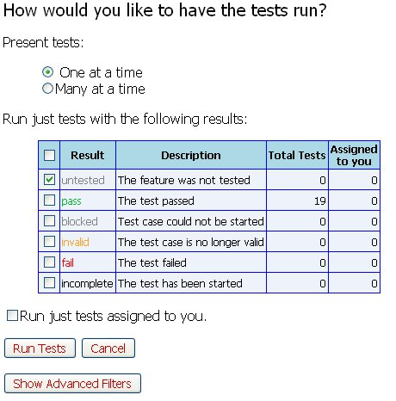
After selecting the tests you can click ‘Run Tests’ and it should start the test session using only those you have selected.

Appending Tests:

To add defect numbers and execution notes you can click the ‘Session Summary’ button mentioned previously. This will launch a pop-up displaying information about test completion, time taken etc.
There is a table named ‘Result Details’ which will display the ‘Test Cases’ as individual rows, each displaying the results and notes for the test case. Select the [Edit Note] in the right most column of the table; this will launch another pop-up into which you can enter the defect number/note.

How to create your Defect attachments on the Mac

Screenshots

To create a screenshot on the Mac simply:

- Hold shift+cmd+4 then press the space bar. This will turn your cursor into a camera.

- Click on the window you want a screenshot of and that will save an image of that window on your desktop.

- Open uk-fs1. If the resultant window displays "connection failed" then click the "connect as..." button and enter your normal pc login details.

- From here navigate to tester_access/ccp/mac2pc and copy and paste the log file from the Mac desktop to this folder.

Log Files

This is a step by step guide for how to run cider and get a log file on a Mac.

- Before you start you are going to want the character you plan reproducing the defect on ready to go with all the preconditions completed. Once you have done this close the client.
- Open the terminal. This should have been added to the Mac dock but if it has not then you can find it in /Applications/Utilities.
- Once inside the terminal type cd followed by a space then drag the client you will be defecting on into the terminal window.
- In the terminal delete the space that appears at the end of the command line then type /contents/MacOS and press enter
- Copy into the terminal ./cider -debugmsg +seh,+tid,+module,+debugstr &> ~/Desktop/EVEcrashlog.log and change EVEcrashlog to your desired file name. Press enter.
- In the client that opens reproduce the defect as quickly as possible then close the client.
Once the log file has been created you will need to move it to your PC so it can be zipped.
- In the Finder select All under Shared in the left panel.
- Open uk-fs1. If the resultant window displays "Connection Failed" then click the "Connect As..." button and enter your normal PC login details.
- From her navigate to Tester_Access/CCP/Mac2Pc and copy and paste the log file from the Mac desktop to this folder.
- On your PC run 7zip.
- Navigate to uk-fs1/Tester_Access/CCP/Mac2Pc and locate your log file.
- Drag and drop your log file into the 7zip window then click OK in the pop-up that is displayed. This will create a zip file of the log in the Mac2PC Folder.
- Attach the zipped log to the relevant defect.

System Details
In place of a dxdiag file you should have a file called e4e-eve-macs-imac saved on your Mac’s desktop. If not you can create one in a few simple steps.
- Click the Apple Icon in the top left of your screen and select About This Mac from the drop down menu.
- In the window that pops up click More Info...
- In the toolbar click on File and select Save. Change the File Format to Plain Text and click on save. This will create a file with all your system information on the desktop.

